

**East West University Staff Management System**

**Project Report**

Course Title: Information System Analysis and Design

Course Code: CSE 347

Section: 04

***Submitted to***

Nishat Tasnim Niloy

Lecturer

Department of Computer Science and Engineering

***Submitted by***

|  |  |
| --- | --- |
| Ziaul Haque Rafi | 2020-1-60-118 |
| Imran Hasan | 2020-1-60-119 |
| Rezmah Jemima Rupin | 2020-1-60-247 |

**Date of Submission: 16 January 2023**

Table of Contents

1. Introduction: 3

2. Features: 3

3. Requirements: 3

3.1. Functional Requirements: 3

3.2. Non-Functional Requirements: 4

4. Complete Use Case Diagram: 5

4.1. Use Case: Level 0 5

4.2. Use Case: Level 1 5

4.3. Use Case: Level 2 6

5. Activity Diagram:

5.1. Structure of ESMS 7

5.2. Authentication 8

5.3. Admin-Employee Activity 9

5.4.Maintain Activity 10

6. Class Diagram: 11

7. Data Flow Diagram:

7.1. Level 0 Data Flow Diagram: 12

7.2. Level 1 Data Flow Diagram: 12

7.3. Level 2 Data Flow Diagram: 13

8. Sequence Diagram: 14

10. Deployment Diagram: 15

11. Final Product: 16

12. Conclusion: 24

**East West University Staff Management System**

# 1. Introduction:

# To run an organization many people has to work for it. This becomes effective when they divide them among themselves. This is why staff management is needed. Staff Management System is the management of all types workers in an organization. Following this system all employees can work in different sectors of an organization according to the given instruction by an admin which leads to effective use of time and labor.

# 2. Features:

1. Admin Panel
2. Employee Panel
3. Different Login pages for admin and employee
4. Guidelines and helplines for users
5. Access to employee profile
6. Modify employee profile
7. Manage employee database
8. Add, remove, update, sort data
9. Record employee’s total work time in database
10. Show Location
11. Contact
12. Salary
13. Paycheck

# 3. Requirements:

## 3.1. Functional Requirements:

* Every user has their own Account.
* Admin will be given a unique ID and Password. Staff will use their phone number because it may be hard for them to remember the ID.
* Proper recovery method will be added to the system in case anyone forgets his id and password
* Date and time for extracurricular event and locations will be mentioned for any notice or events.
* Guidelines and helpline will help the users to navigate through the system.
* Employee Category will be mentioned.
* Employee database will be visible to the admin only. He will modify those data.
* Admin can check individual Employee profile.
* Admin can also search for a specific Employee by category.
* Admin will record every Employee’s salary and working hour and also Phone number in any emergency.
* Database list can be sorted according to either of the above data.
* Employee’s check in and check out time will be recorded and total work time will be calculated accordingly.
* If any employee works overtime that will be counted as bonus with his usual salary.
* Each and every employee information can be accessible by admin.
* User can share their feedback or any suggestion. They can choose to keep their information anonymous
* Admin will respond to any query sent from any employee.
* User’s salary will be calculated according to their work time each day for the whole month.
* User can sort that monthly data and figure out which day he earned the most.
* Employee’s personal information such as email, phone, address, educational background etc. will be displayed.

## 3.2. Non-Functional Requirements:

1. Usability - Should be user friendly.
2. Reliability - The system should be available to users for all the time.
3. Scalability - How fast does the system return results and how much will this performance change with higher workloads.
4. Maintainability - System should be easy to maintain and cost effective.
5. Security - The system and its data must be protected against attack. ** confuse to implementation.

# 4. Complete Use Case Diagram:

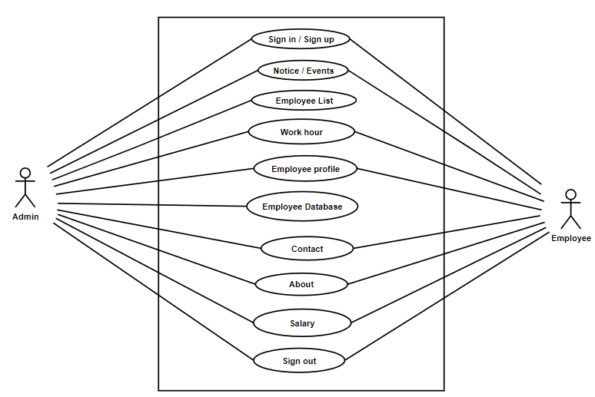

## 4.1. Use Case: Level 0

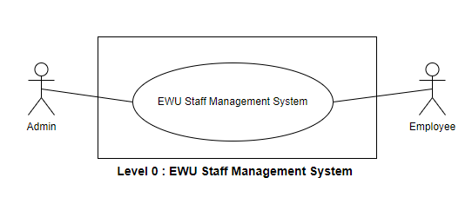

## 4.2. Use Case: Level 1

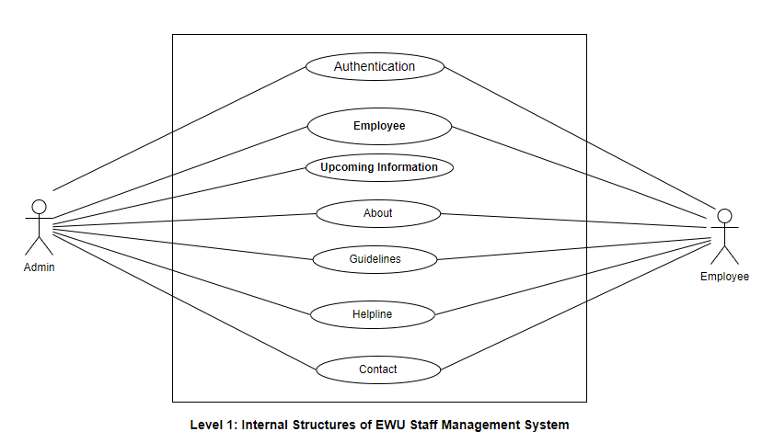

## 4.3. Use Case: Level 2

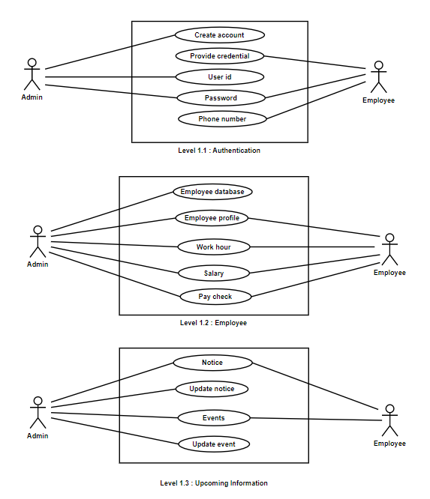

Fig: Use case of Level 2

# 5. Activity Diagram (Swim lane):

## 5.1. Structure of ESMS

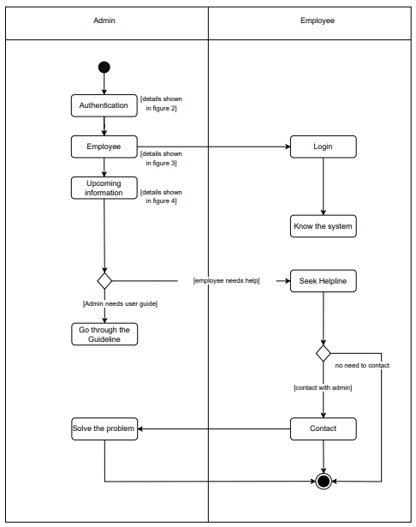

Fig: Structure (From level 1)

## 5.2. Authentication

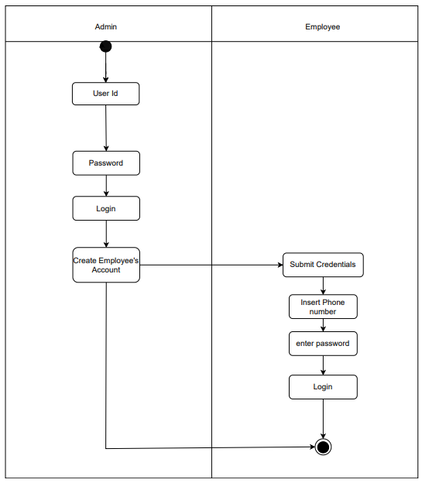

Fig: Authentication (From level 1.1)

## 5.3. Admin-Employee Activity

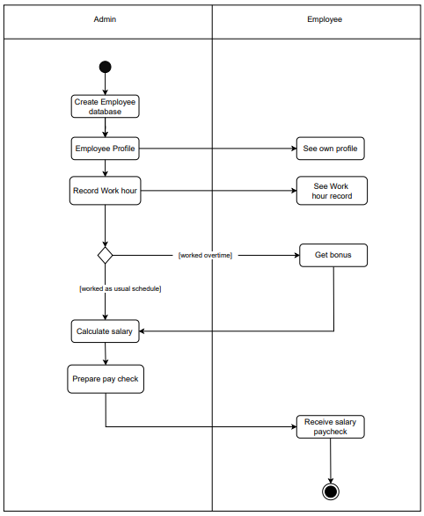

Fig: Admin-Employee Activity (From level 1.2)

## 5.4. Maintain Activity

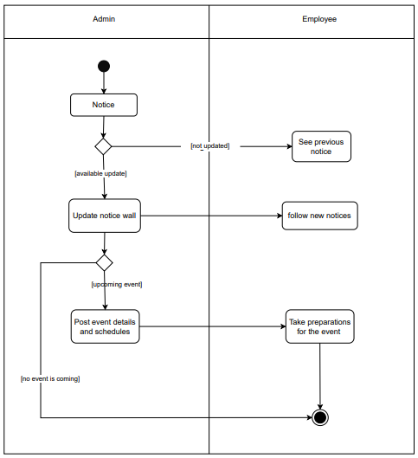

Fig: Maintain Activity (From level 1.3)

6. Class Diagram:

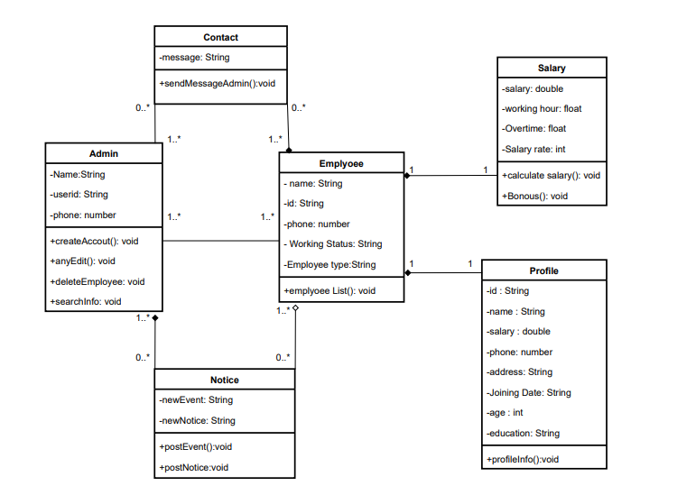

# 

# Fig: Class Diagram

# 7. Data Flow Diagram:

## 7.1. Level 0 Data Flow Diagram:

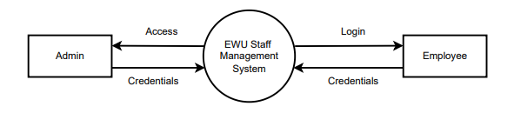

Fig: Level 0 Data Flow Diagram

## 7.2. Level 1 Data Flow Diagram:

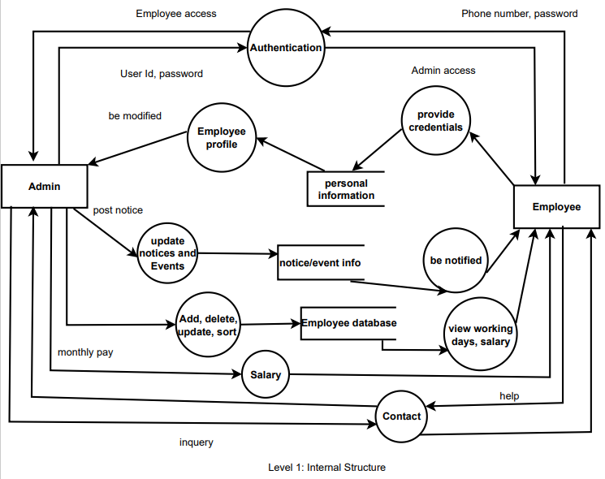

Fig: Leve 1 Data Flow Diagram

## 7.3. Level 2 Data Flow Diagram:

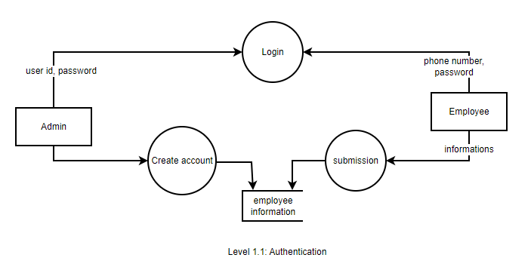

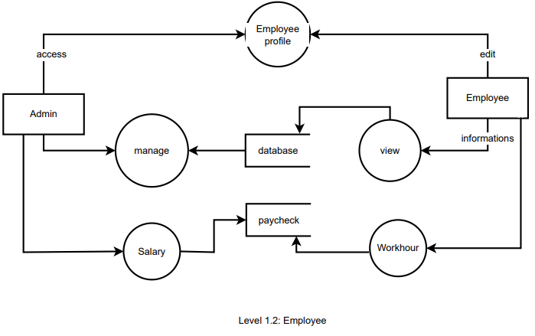

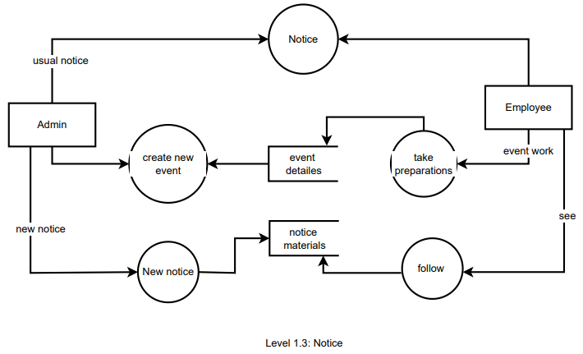

Fig: Leve 2 Data flow Diagram

# 8. Sequence Diagram:

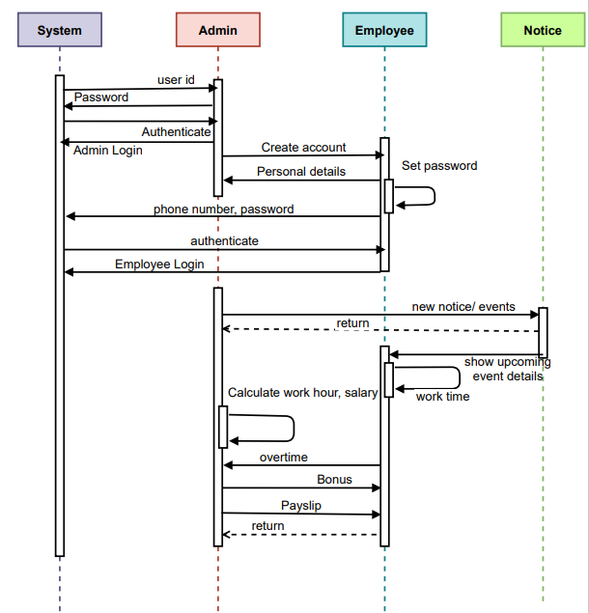

Fig: Sequence diagram

9. Deployment Diagram:

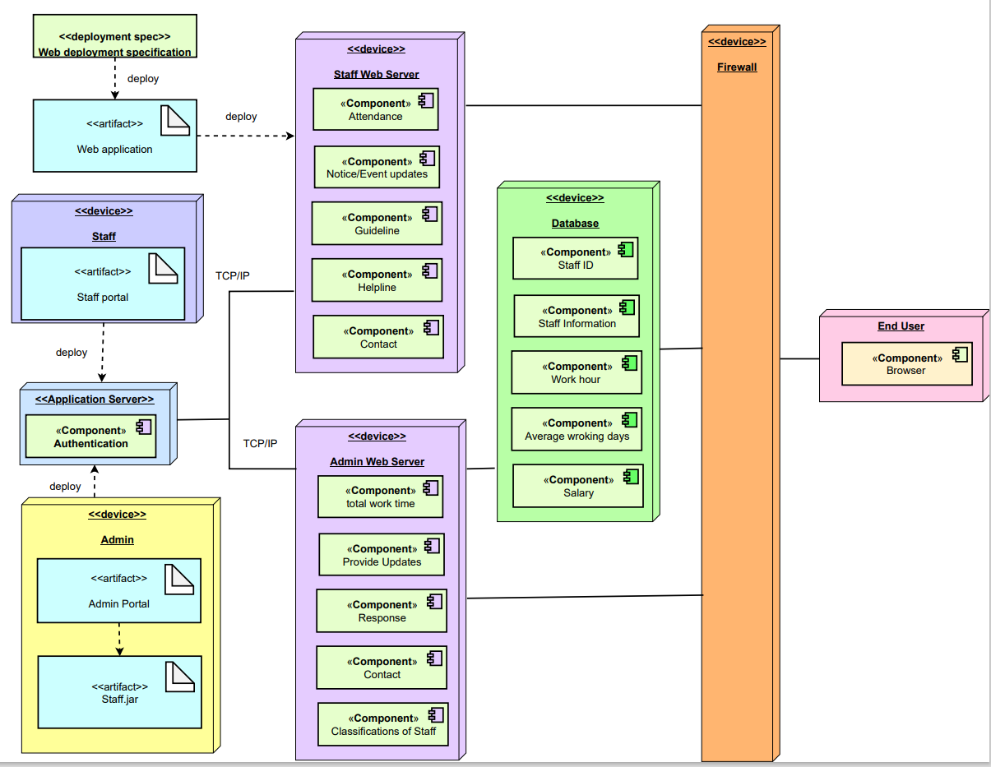

# 

# Fig: Deployment Diagram

# 10. Final Product:

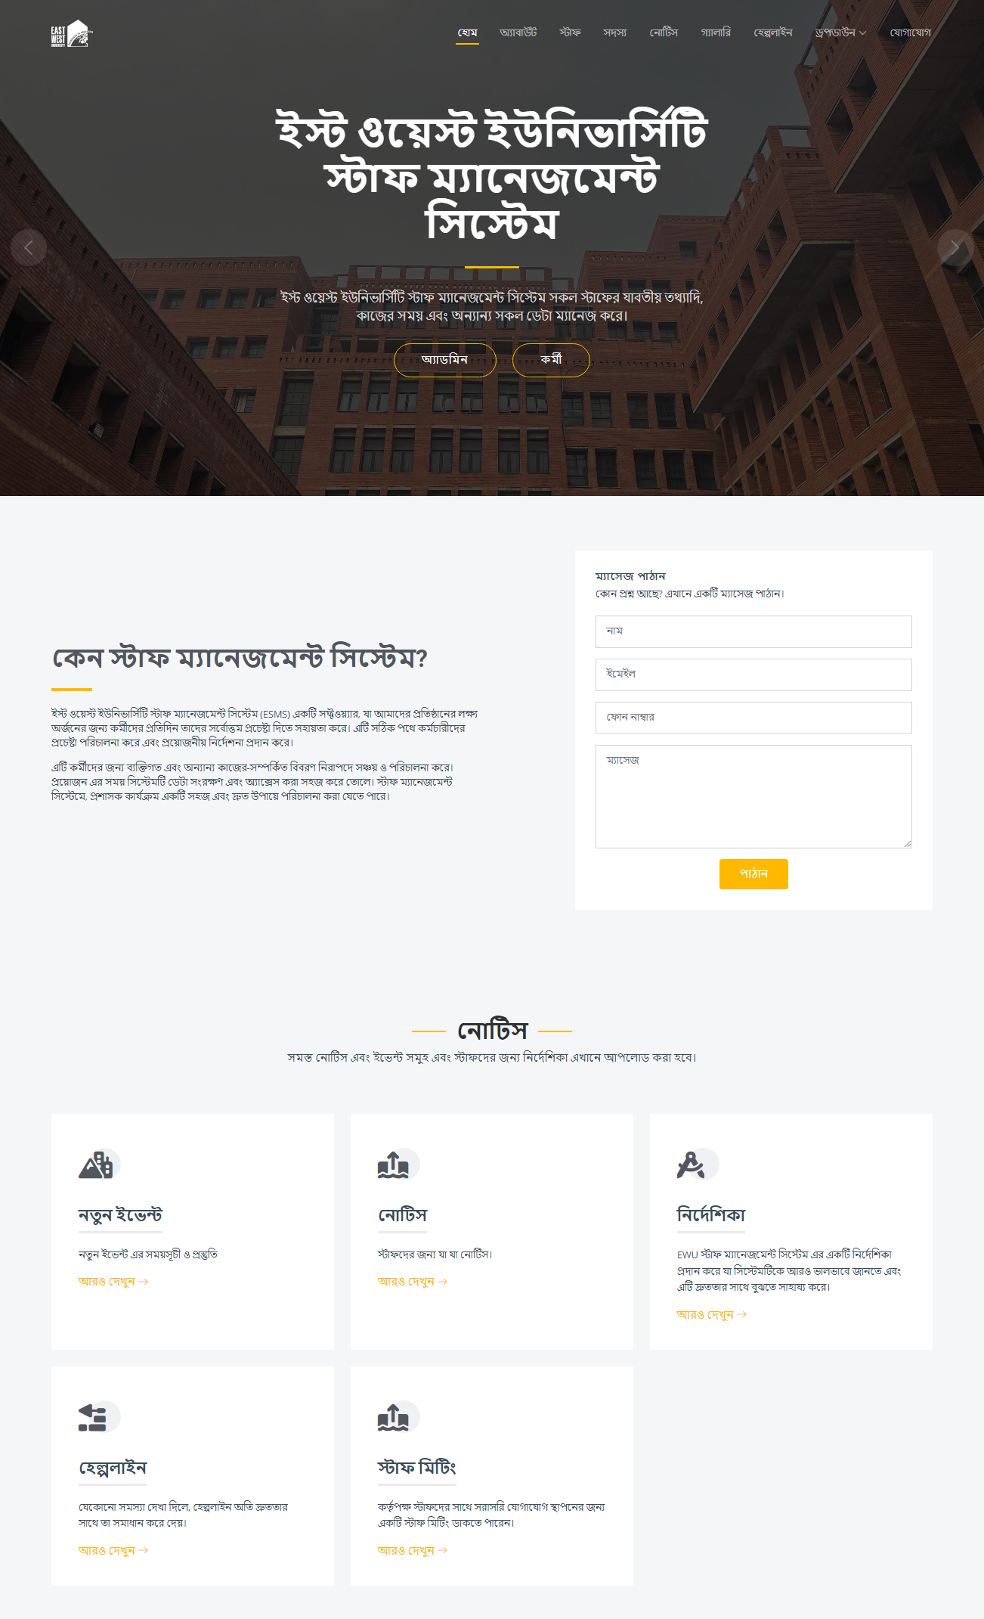

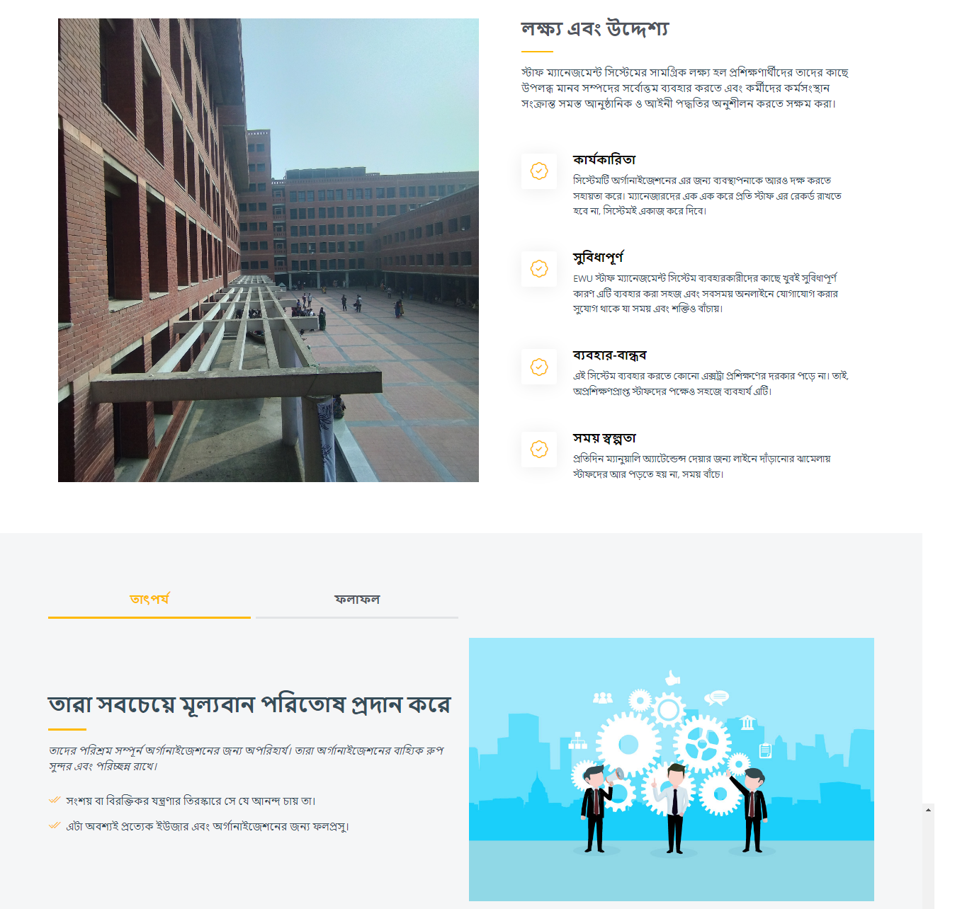

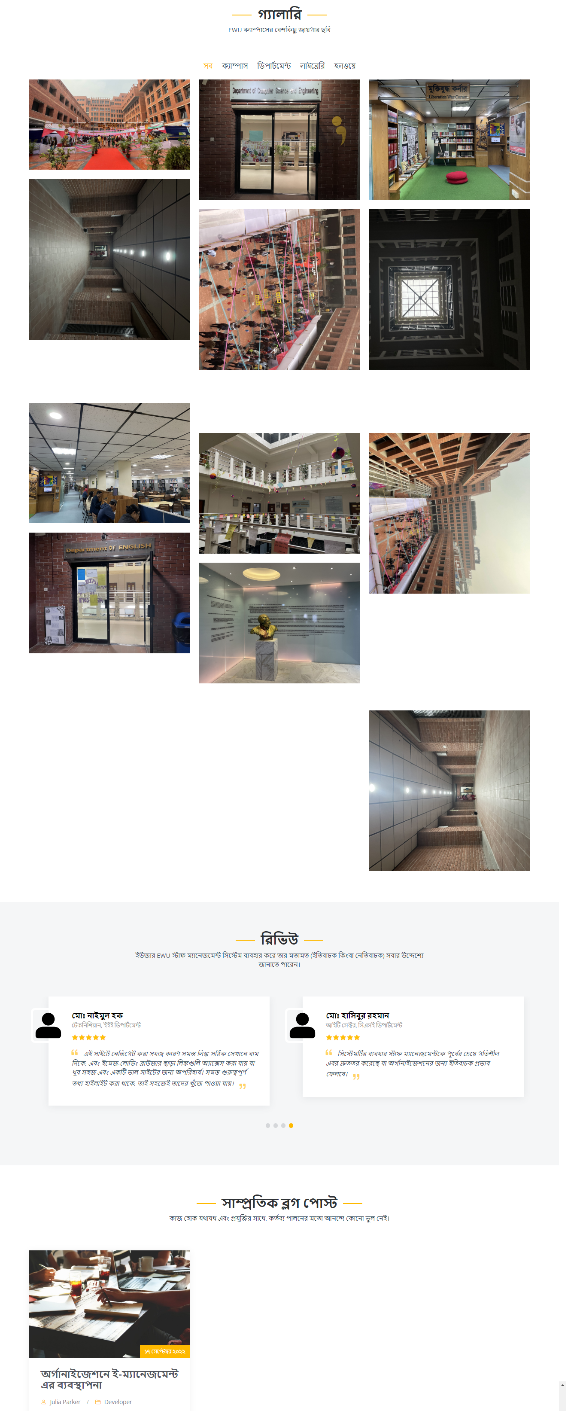

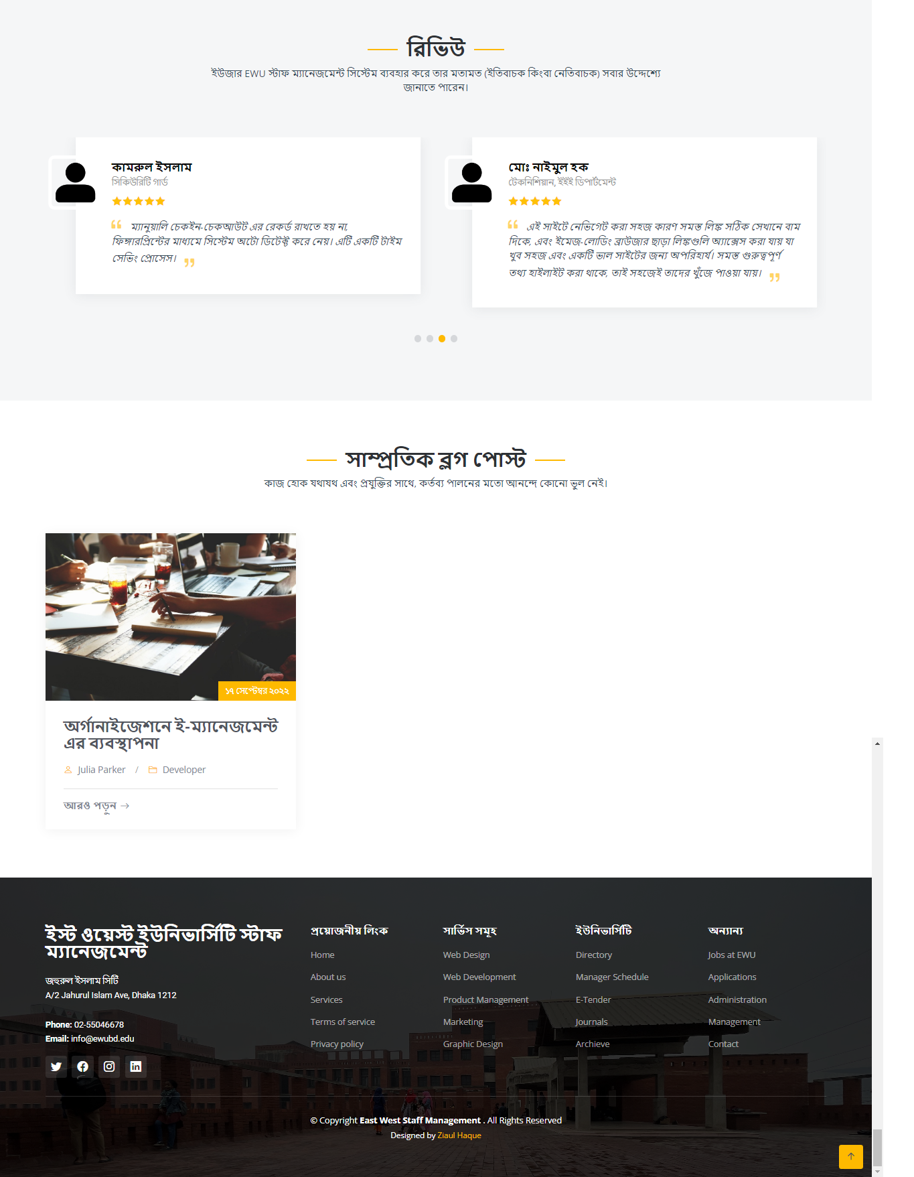

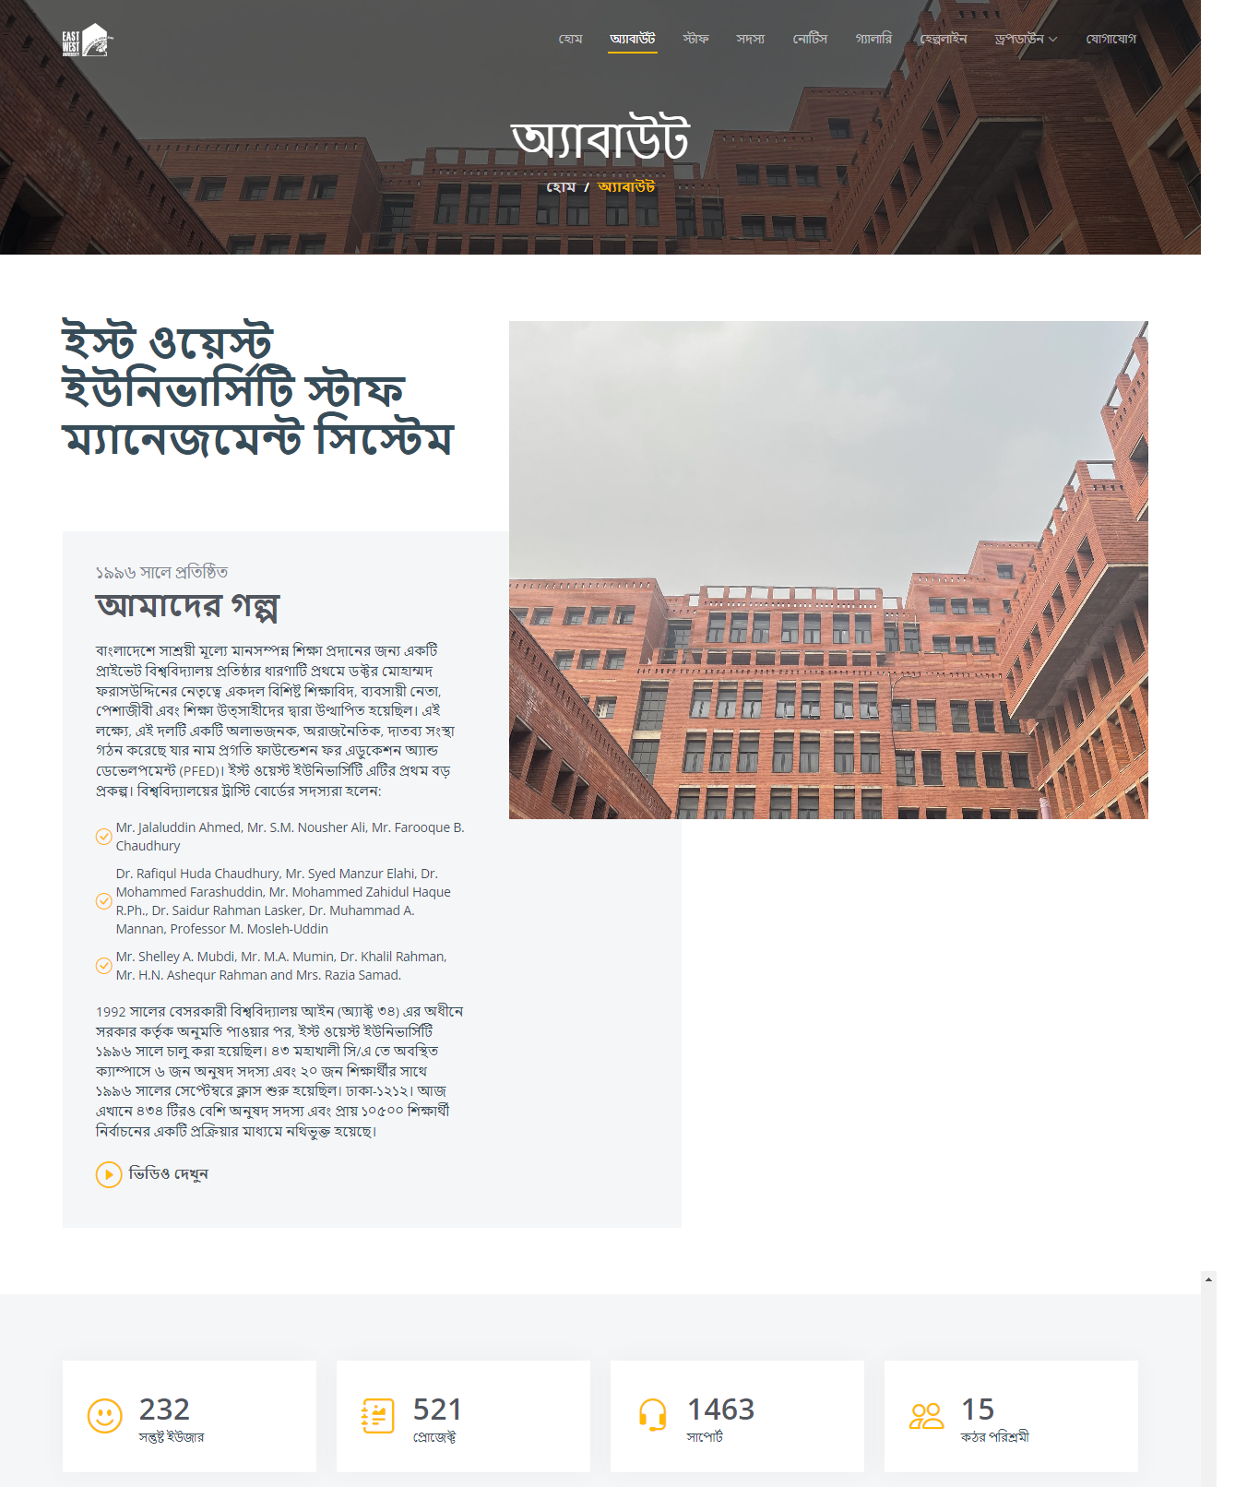

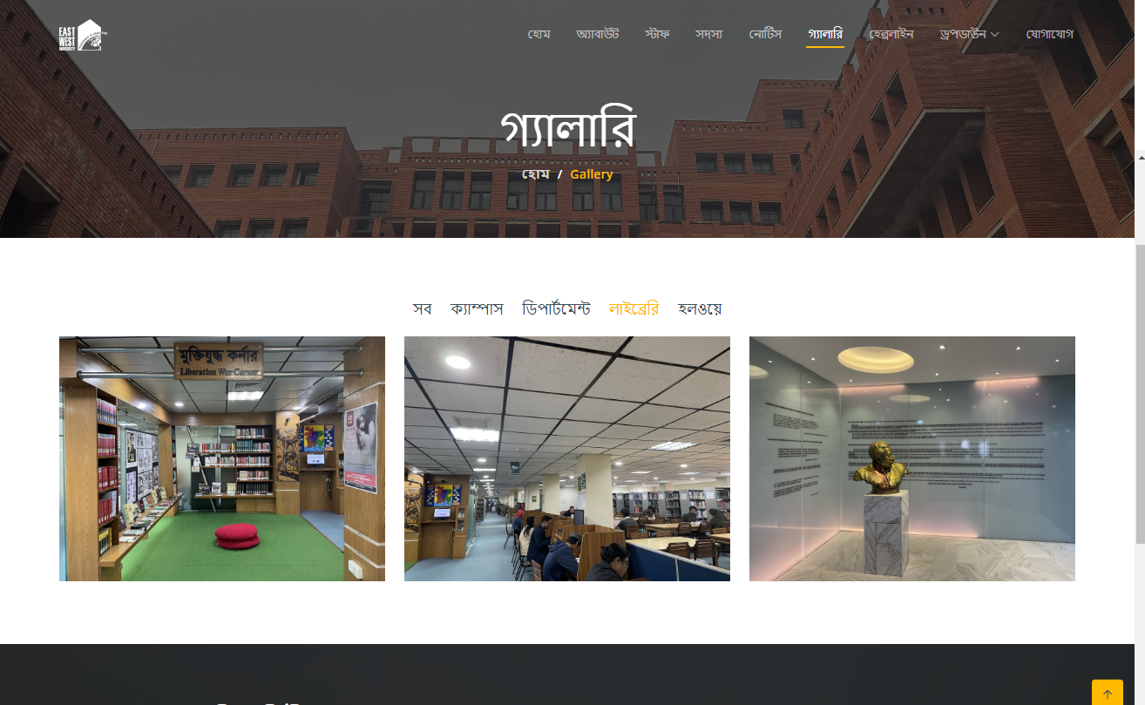

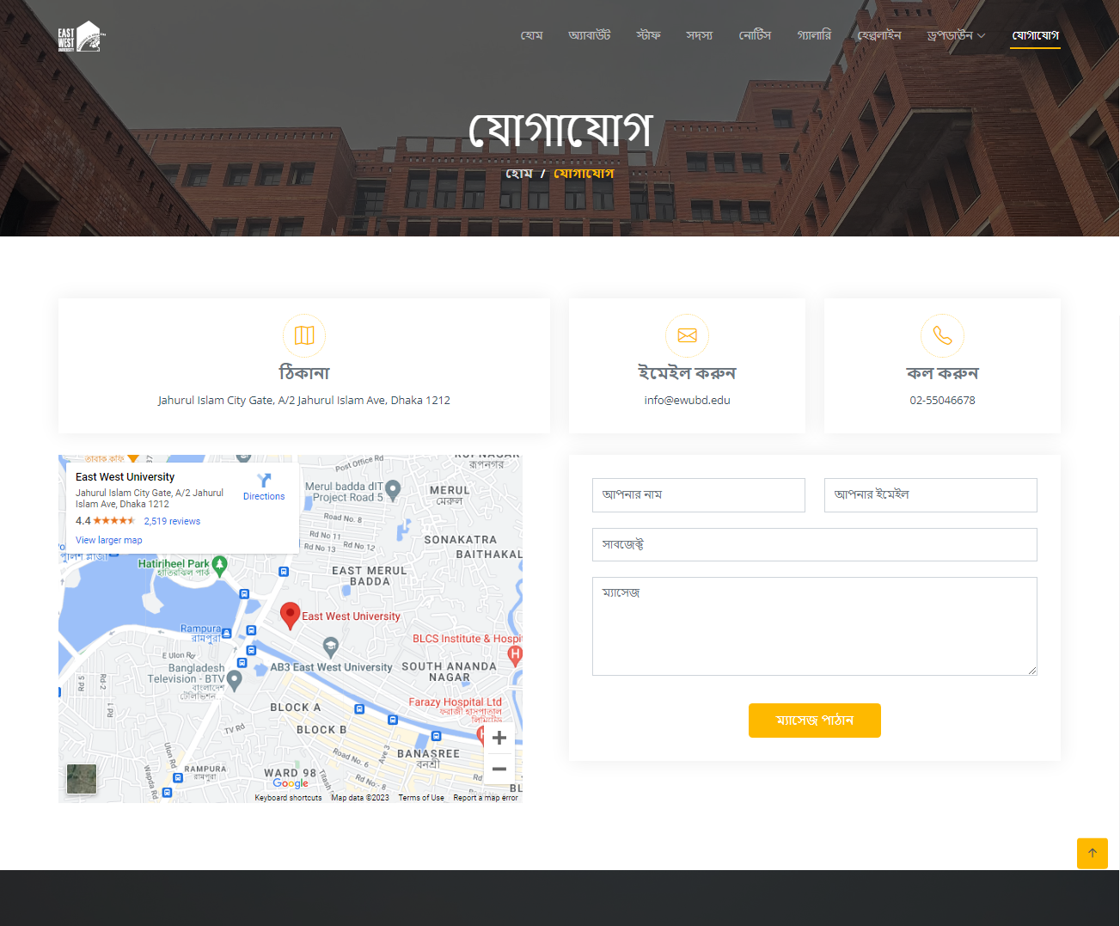



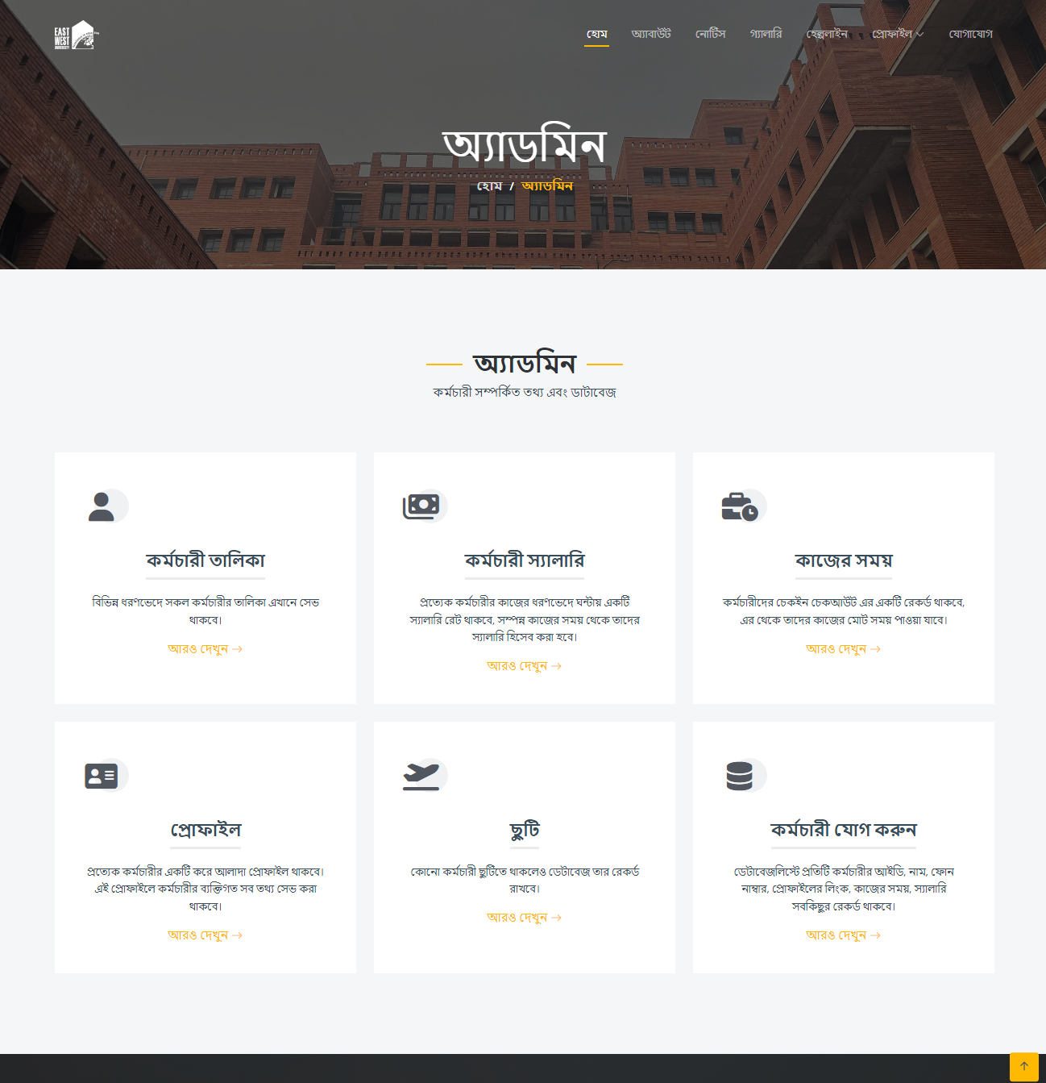

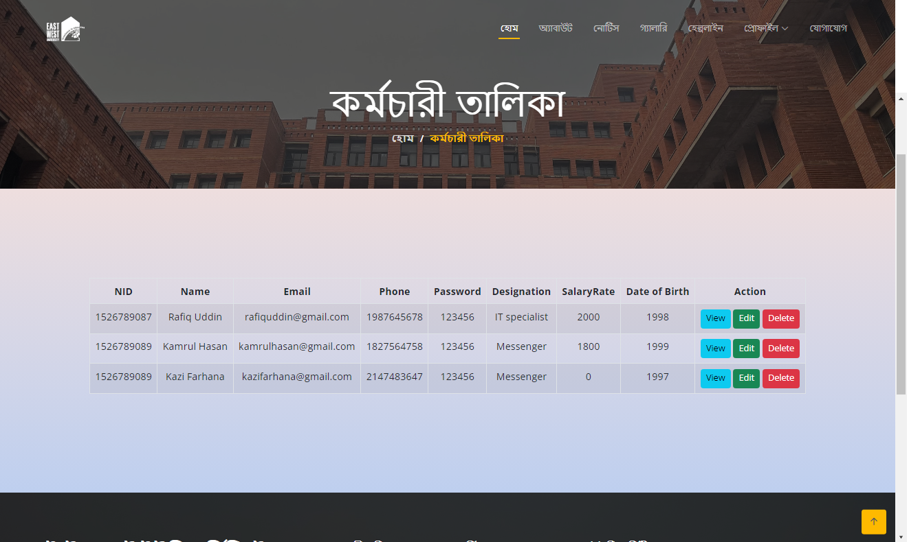

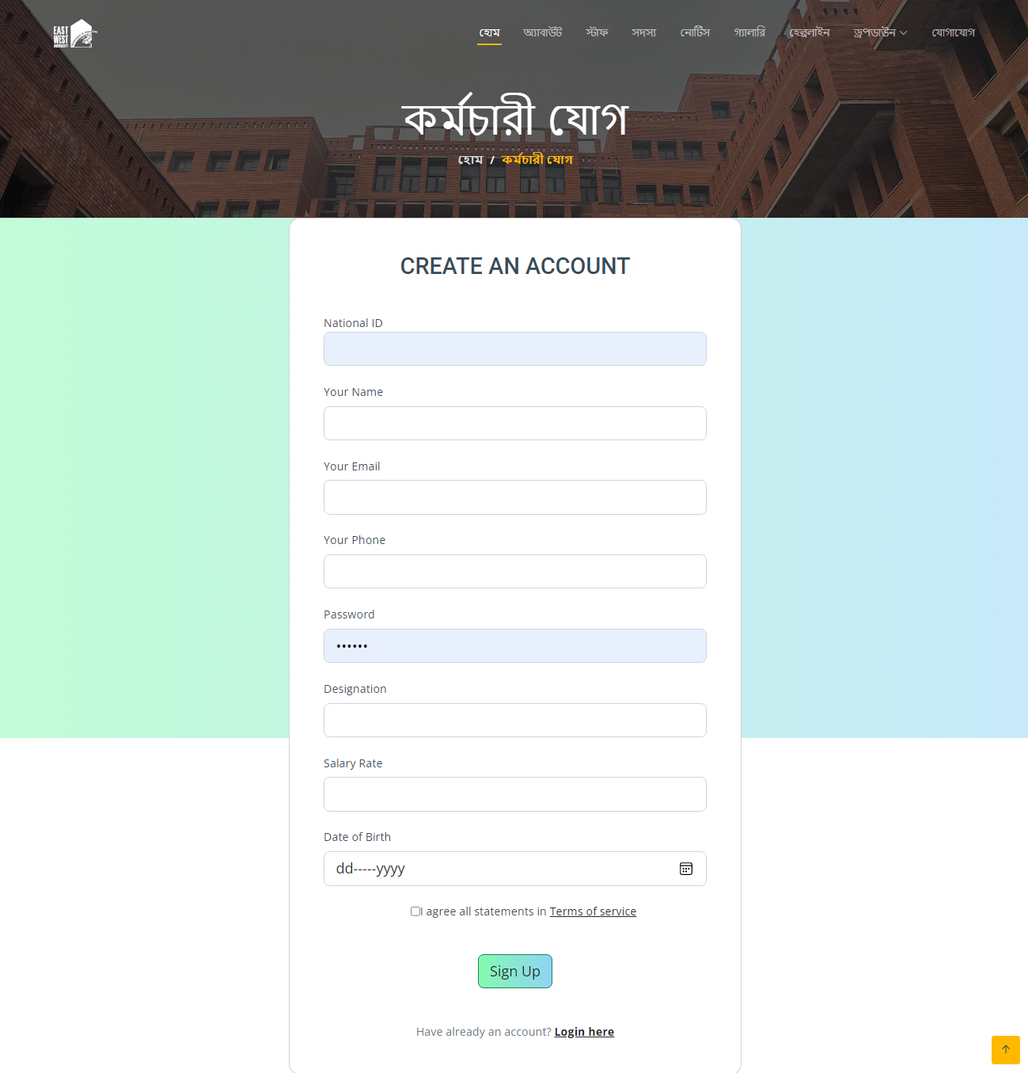



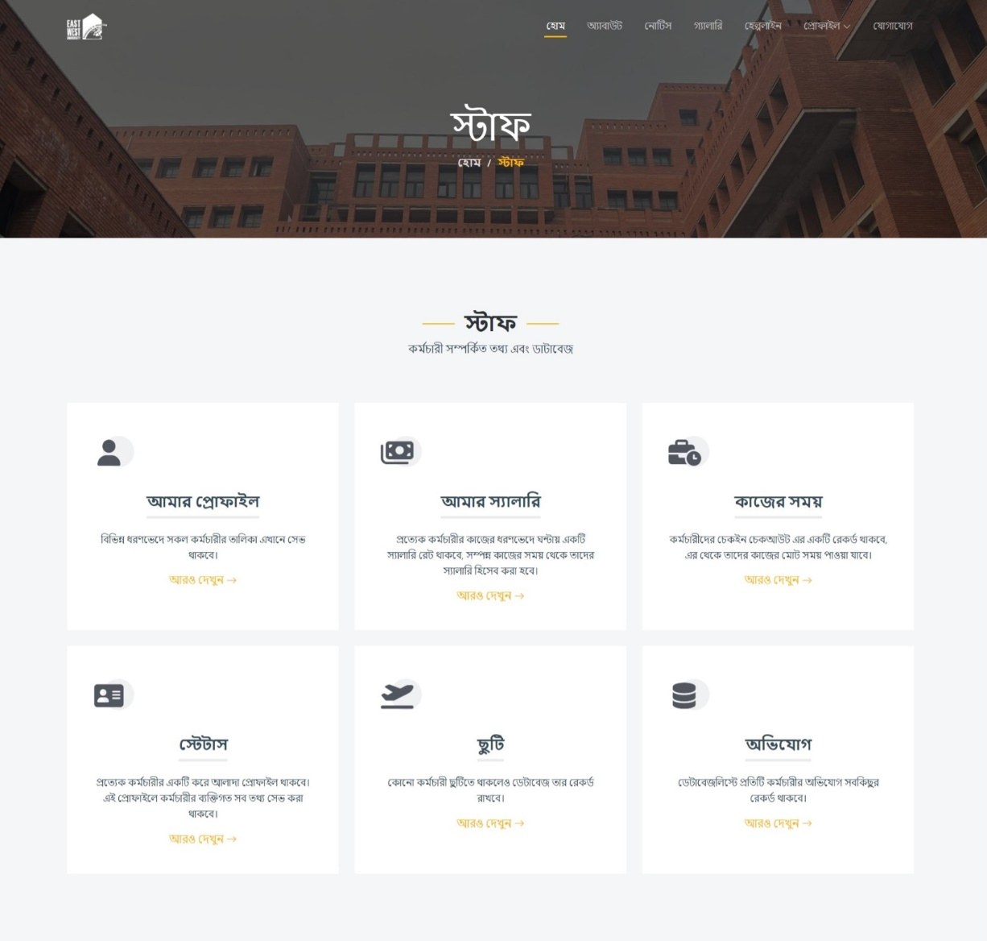

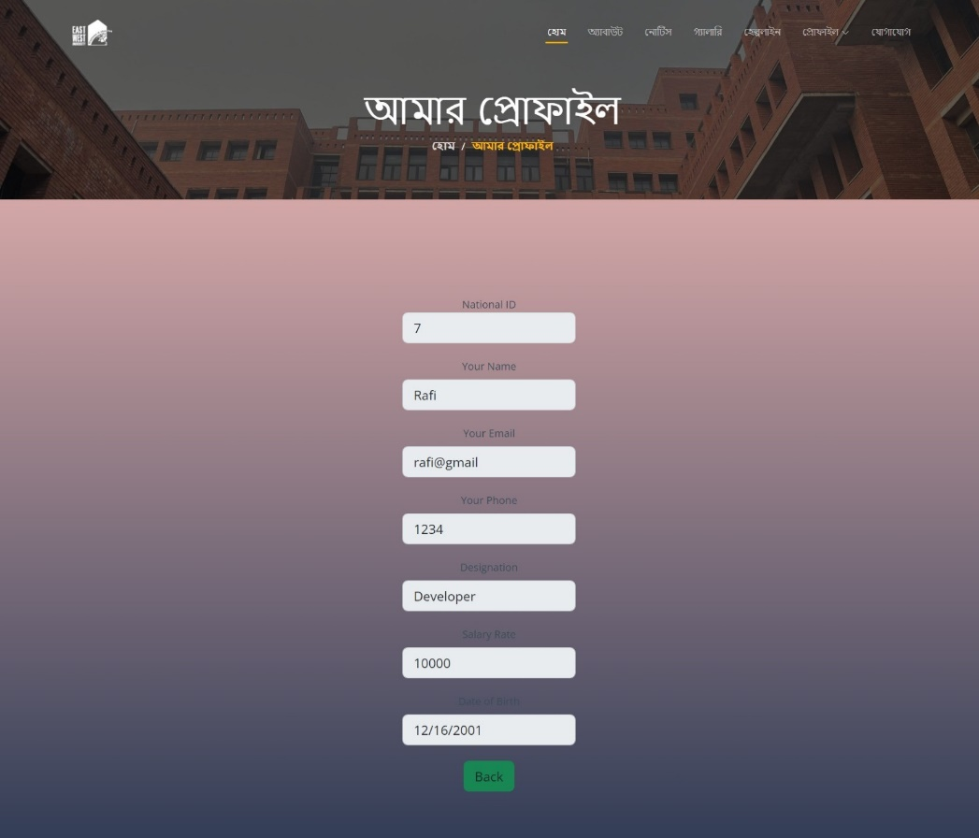

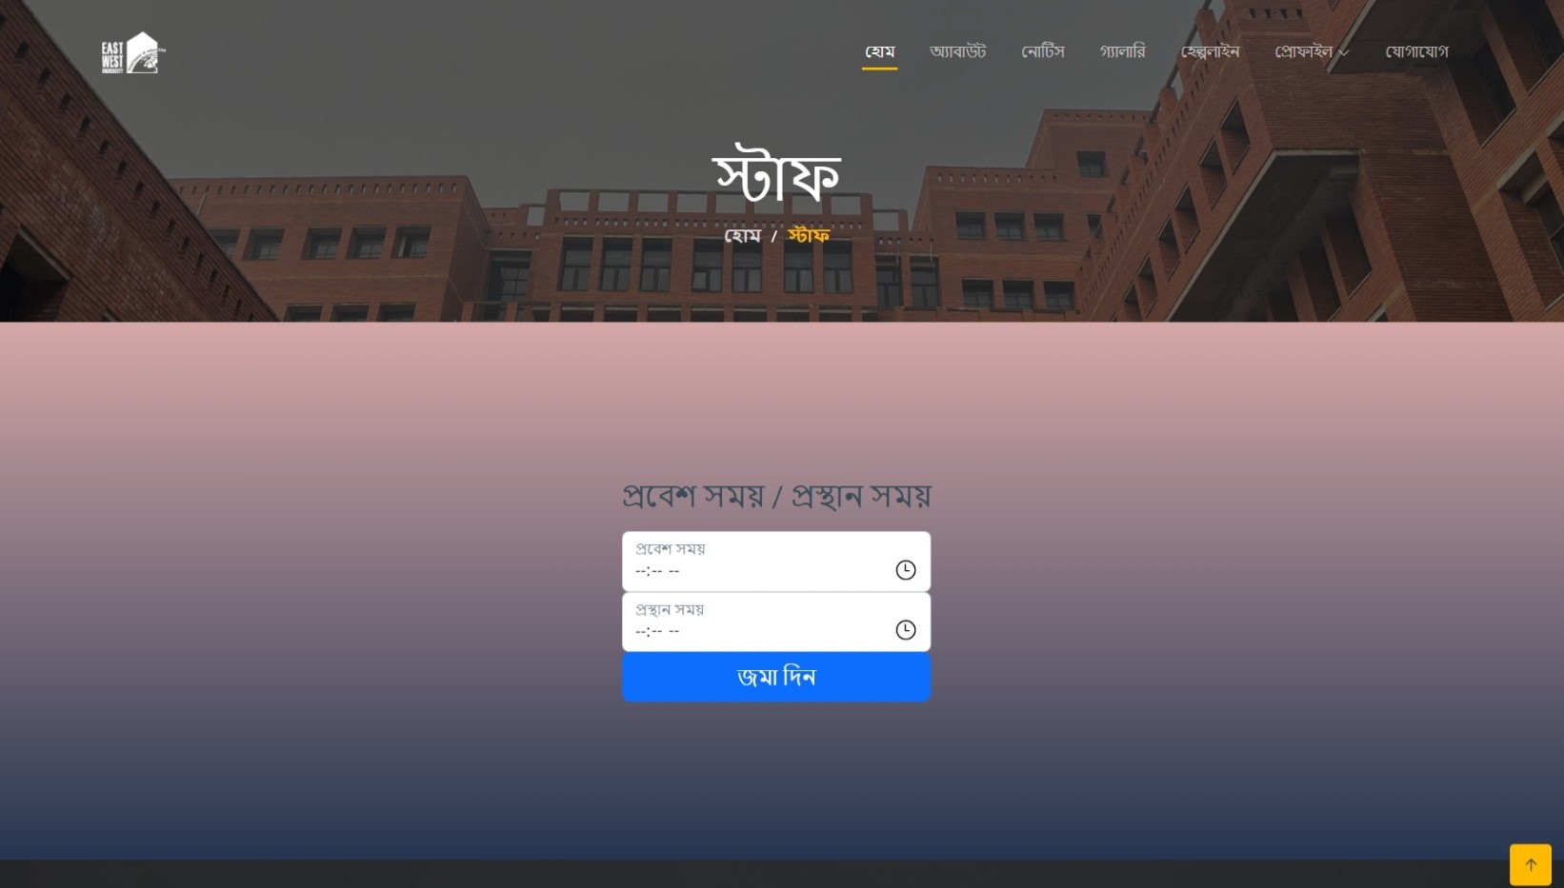

# 11. Conclusion:

East West University Staff Management System is built to lead all the workers in a disciplined way. When the staff are instructed their duties properly the organization runs in an effective way. EWU Staff Management System make this simpler for all the workers. An admin helps the staff to along with the system properly and maintains the employee database.